BRAC UNIVERSITY
Department of Computer Science and Engineering

Examination: Mid Semester Exam  Duration: 1 Hour 20 Minutes | Semester: Spring 2024  Full Marks: 35
CSE 221: Algorithms

Answer the following questions.
Figures in the right margin indicate marks.

Name: | ID: | Section:

1 | a.  CO2 | Consider the following functions.  $f_{1}(n) = log (n{!)}^{}$  $f_{2}(n) = n^{2} log_{n}(n^{n})$  $f_{3}(n) = n^{4}+10n^{2}$  $f_{4}(n) = 17.13^{n}$  $f_{5}(n) = n log n$  $f_{6}(n) = n*\sqrt[5]{n^{2}}$  Write a correct asymptotic upper bound for each of the above and sort the functions in ascending order of their growth rate.  Solution:  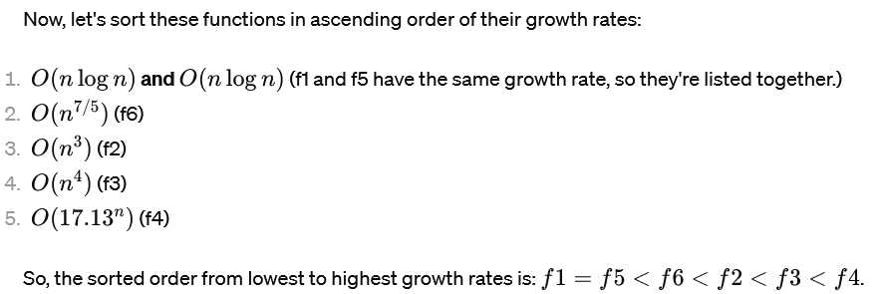 | 03
 | b.  CO2 | Write the asymptotic time complexity of the following code snippet. Show your works/reasoning.  - for i in range (1,n)  - j= 1  - while j < i*i  - j= j-1  Solution: Infinite Loop | 03
 | c.  CO2 | Express the following (either one of the two) running time $T(n)$ with an asymptotic bound.  $T(n) = 8T(\frac{n}{4}) +n√n Or T(n)=2T(n-2)+1$  Any method is acceptable as long as you show calculations.  Solution:  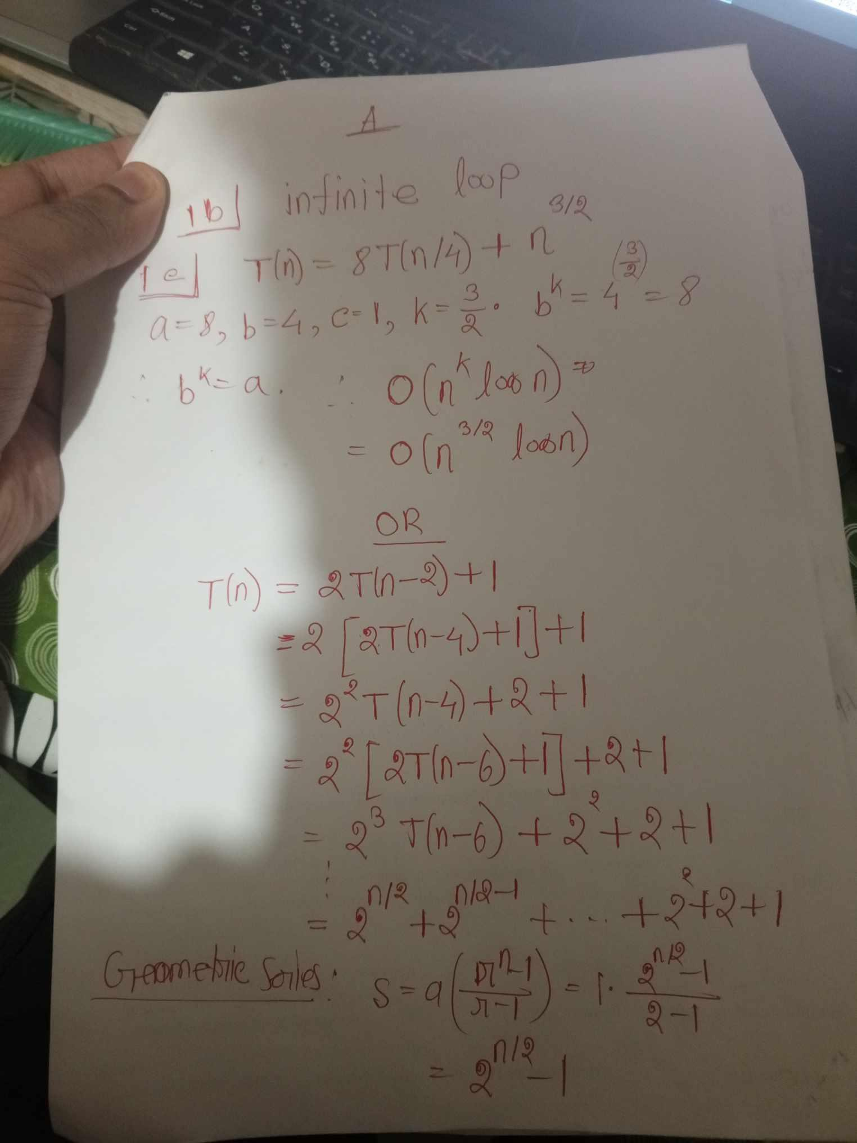 | 04
2 | CO1 | i. By showing necessary math, explain how Karatsuba's Fast Multiplication algorithm converts an N-digit multiplication to three N/2-digit multiplications.  ii. Can we modify the algorithm to multiply two N-bit binary numbers? Explain how or why not.  Solution:  i. 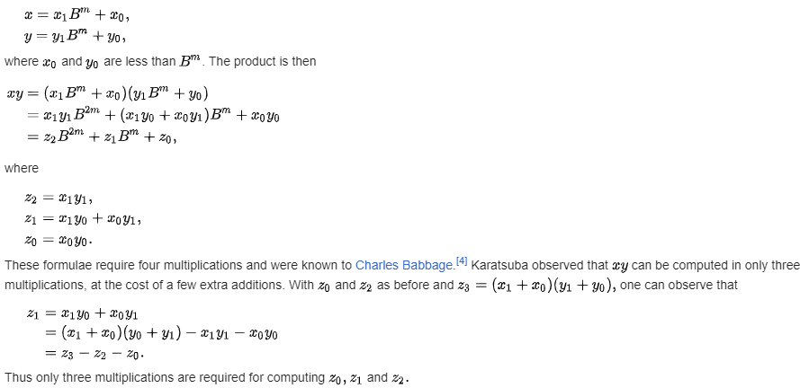  source: https://en.wikipedia.org/wiki/Karatsuba_algorithm  ii. Just set B for any base. | 03  02
3 | a.  CO1 | Write the worst case time complexity of quick sort? Illustrate an array where the worst case of quick sort occurs if the last element is chosen as pivot.  Solution:  Worst case complexity: O(N²)  Worst case input: all sorted in either ascending or descending order. | 04
 | b.  CO3  CO2 | Consider an array containing N unique values where for some index i, the values are in increasing order from index 0 to (i-1), and then again from i to (N-1). Moreover, it is guaranteed that all the values from index 0 to (i-1) are greater than all the values from i to (N-1).  An example array is given below.  index 0 1 2 3 4 5 6 7  value 9 12 15 2 4 5 7 8  Here i=3, it means the values are in increasing order from index 0 to 2, and then again from 3 to 7. Also, all values from index 0 to 2 are greater than all values from 3 to 7 (it is guaranteed, no checking required).  Given such an array, propose an algorithm to find the index i.  i) Write your algorithm with a code/pseudocode/flowchart/step-by-step instructions.  ii) Write the time complexity of your algorithm.  Solution:  Algorithm: Alike binary search, take mid from current left, right. If A[mid] < A[0], i is on the left side. Otherwise, either mid is i or i is on the right side. So do i= mid and then search on the right side.  Complexity: O(log₂N)  Can also be done in linear time by comparing current index i with (i-1) or (i+1)  Wrong solution: any attempt where original indices are lost | 04  02
4 | CO1 | You are a computer science student and you are given a file structure encoded in a graph. You want to make a navigator system where if a person wants to find a file they can enter the name of the file and your program will return the exact location of the file.  For example, consider the following graph:  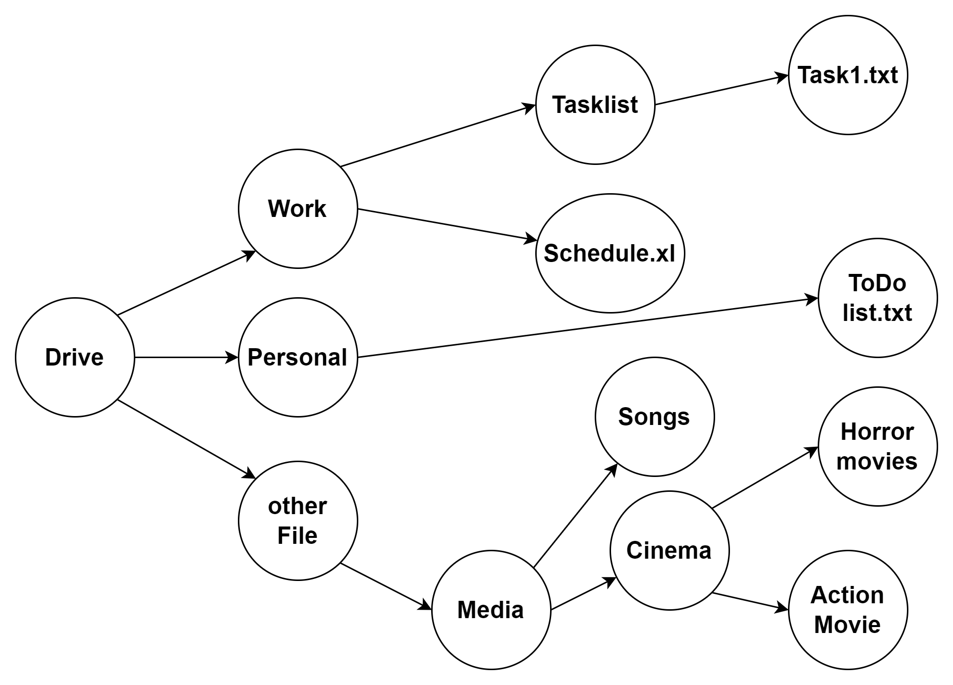  If the user wants to find task1.txt; your program will give the following output: Drive->Work->Tasklist->task1.txt  If the user wants to find Horror Movies; your program will give the following output:  Drive->other file->Media->Cinema->Horror Movies  Now answer the following questions:  - Give the adjacency list representation of this graph. You can use either the whole name or a shorter version of each node.  - Write the name of your preferred algorithm to solve the above mentioned problem (a navigator system). Explain your reasoning in brief.  - Show a simulation of your presented solution with proper use of data structure and other necessary details to give the desired answers as the sample input shows.  Solution: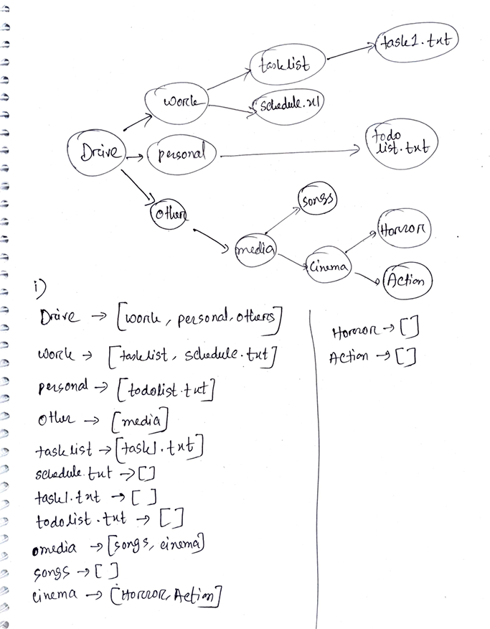  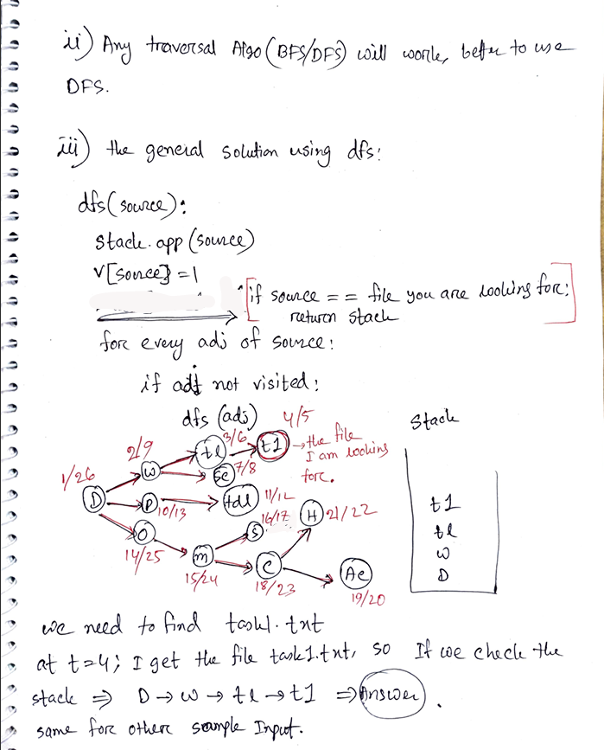  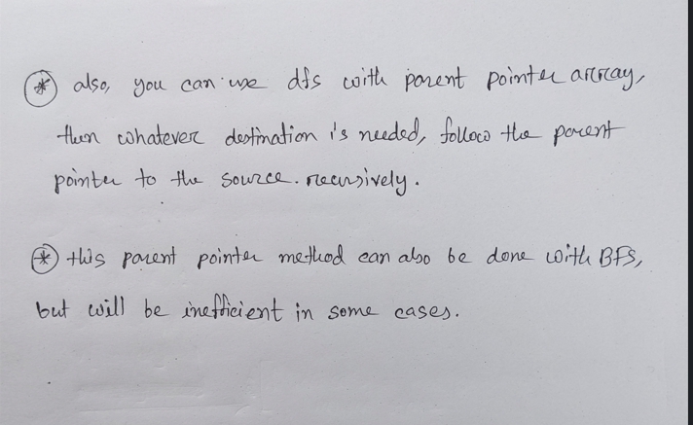 | 03  02  05

BRAC UNIVERSITY
Department of Computer Science and Engineering

Examination: Mid Semester Exam  Duration: 1 Hour 20 Minutes | Semester: Spring 2024  Full Marks: 35
CSE 221: Algorithms

Answer the following questions.
Figures in the right margin indicate marks.

Name: | ID: | Section:

1 | a.  CO2 | Consider the following functions.  $f_{1}(n) = log (n{!)}^{}$  $f_{2}(n) = n*\sqrt[4]{n^{2}}$  $f_{3}(n) = n^{3}+10n^{2}$  $f_{4}(n) = 17.13^{n}$  $f_{5}(n) = n log n$  $f_{6}(n) = n^{2} log_{n}(n^{n})$  Write a correct asymptotic upper bound for each of the above and sort the functions in ascending order of their growth rate. | 03
 | b.  CO2 | Write the asymptotic time complexity of the following code snippet. Show your works/reasoning.  - for i in range (1,n)  - j= 1  - while j < i*i  - j= j+1  Solution : 1^2+2^2+3^2+......+n^2 = O(n^3) | 03
 | c.  CO2 | Express the following (either one of the two) running time $T(n)$ with an asymptotic bound.  $T(n) = 4T(\frac{n}{4}) +√n Or T(n)=T(n-3)+n$  Any method is acceptable as long as you show calculations. | 04
 |  | 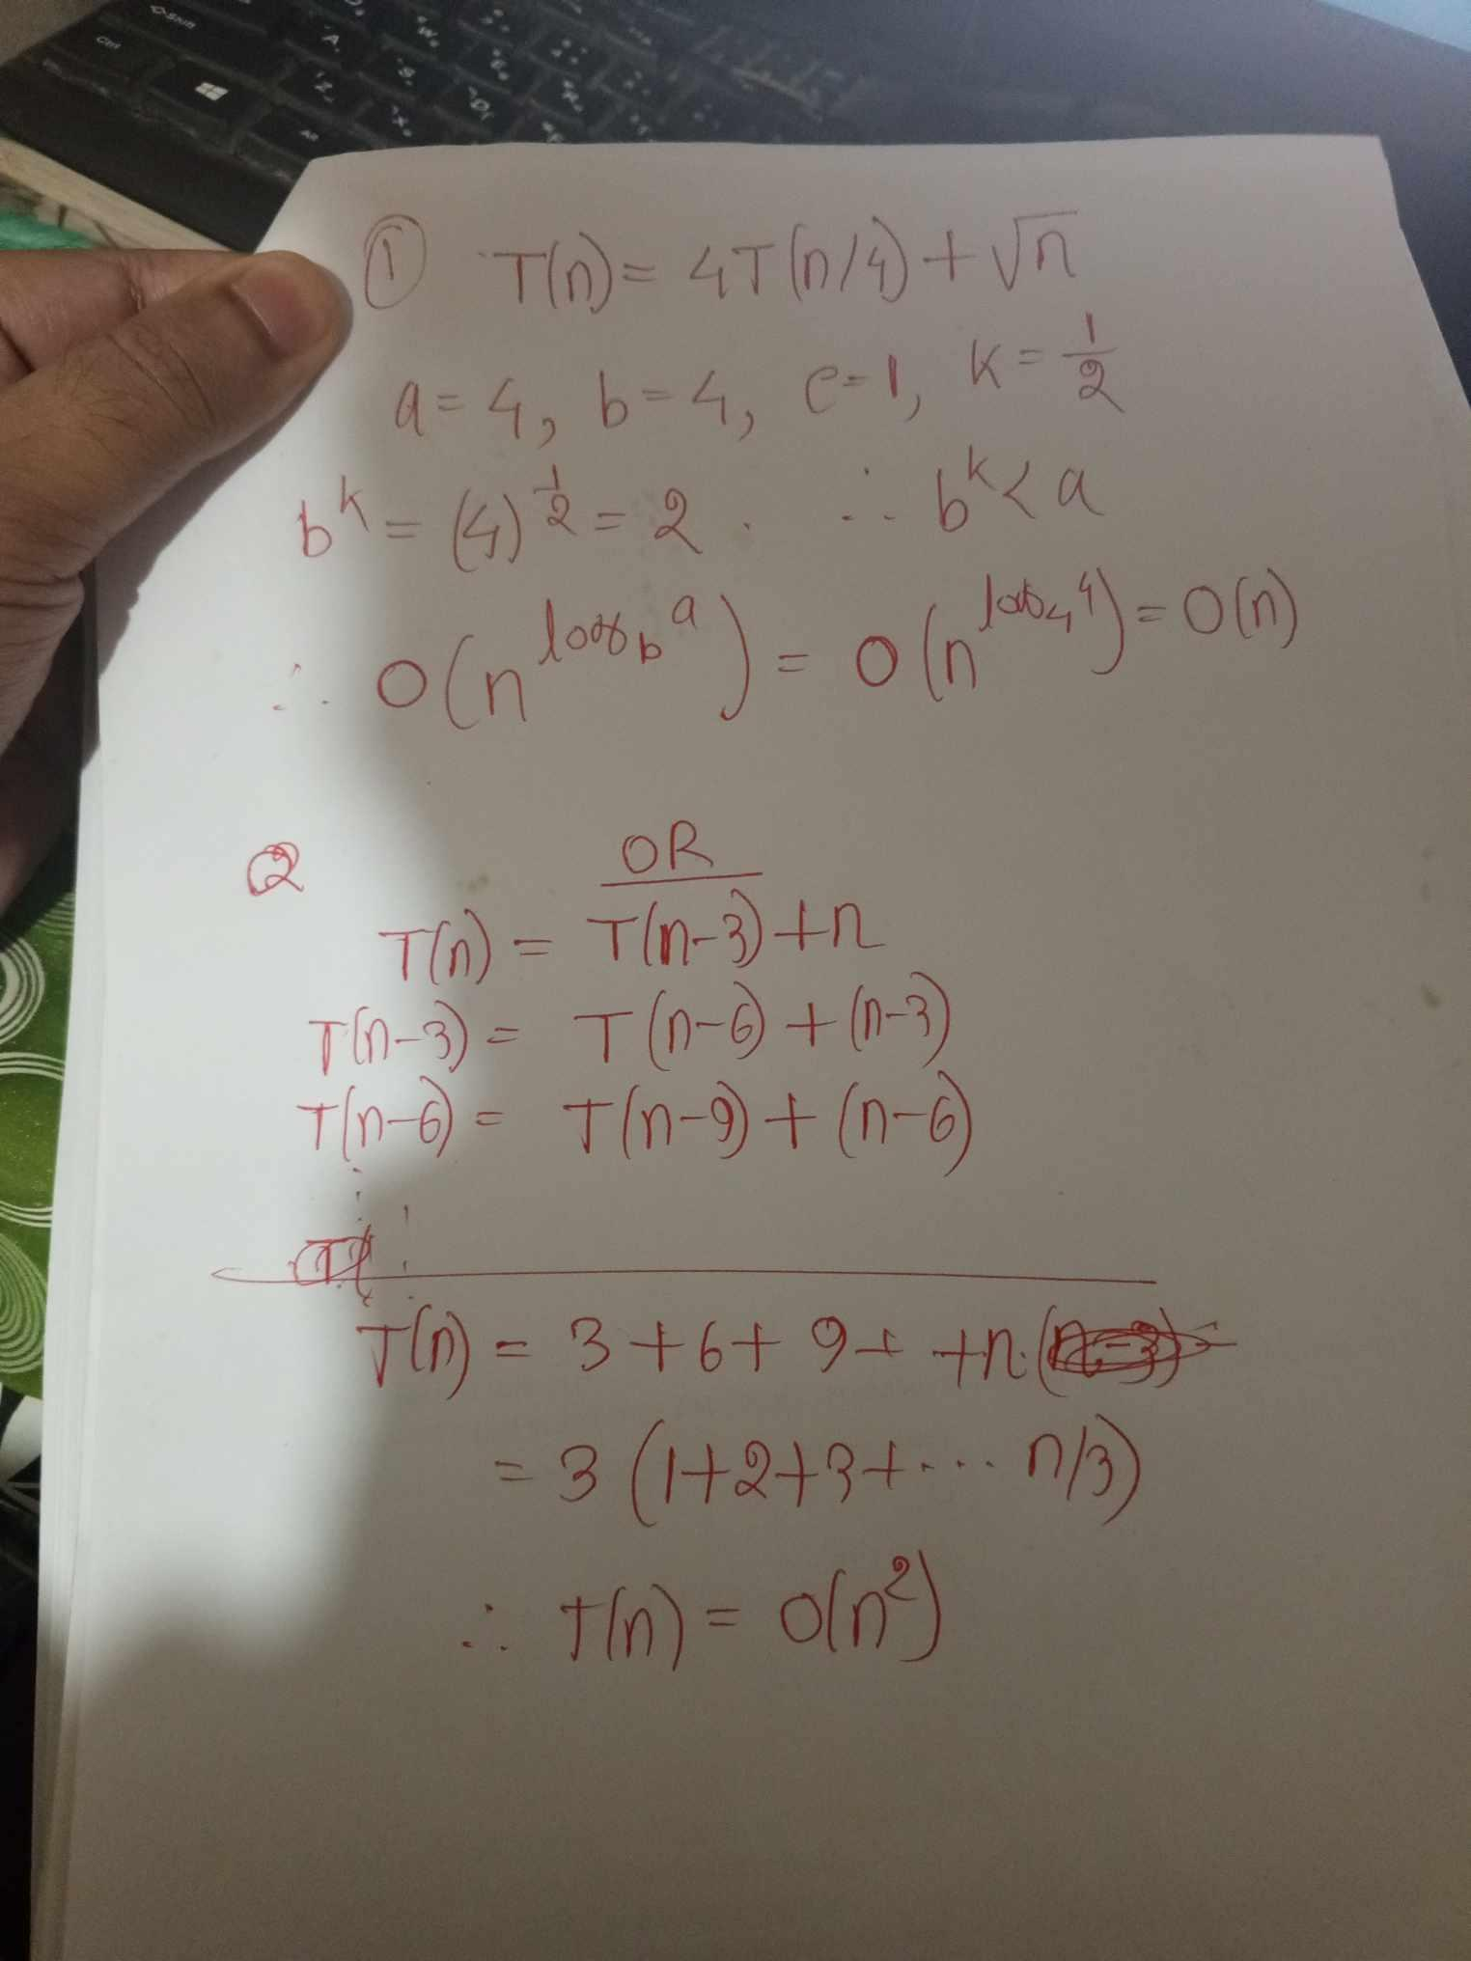
2 | CO1 | i. By showing necessary math, explain how Karatsuba's Fast Multiplication algorithm converts an N-digit multiplication to three N/2-digit multiplications.  ii. Can we modify the algorithm to multiply two N-digit hexadecimal numbers? Explain how or why not.  Solution: Same as set A. | 03  02
3 | a.  CO1 | Write the worst case time complexity of quick sort? Illustrate an array where the worst case of quick sort occurs if the first element is chosen as pivot.  Solution:  Worst case complexity: O(N²)  Worst case input: all sorted in either ascending or descending order. | 04
 | b.  CO3  CO2 | Consider an array containing N unique values where for some index i, the values are in decreasing order from index 0 to (i-1), and then again from i to (N-1). Moreover, it is guaranteed that all the values from index 0 to (i-1) are smaller than all the values from i to (N-1).  An example array is given below.  index 0 1 2 3 4 5 6 7  value 5 4 1 12 10 9 7 6  Here i=3, it means the values are in decreasing order from index 0 to 2, and then again from 3 to 7. Also, all values from index 0 to 2 are smaller than all values from 3 to 7 (it is guaranteed, no checking required).  Given such an array, propose an algorithm to find the index i.  i) Write your algorithm with a code/pseudocode/flowchart/step-by-step instructions.  ii) Write the time complexity of your algorithm.  Solution:  Algorithm: Alike binary search, take mid from current left, right. If A[mid] > A[0], i is on the left side. Otherwise, either mid is i or i is on the right side. So do i= mid and then search on the right side.  Complexity: O(log₂N)  Can also be done in linear time by comparing current index i with (i-1) or (i+1)  Wrong solution: any attempt where original indices are lost | 04  02
4 | CO1 | 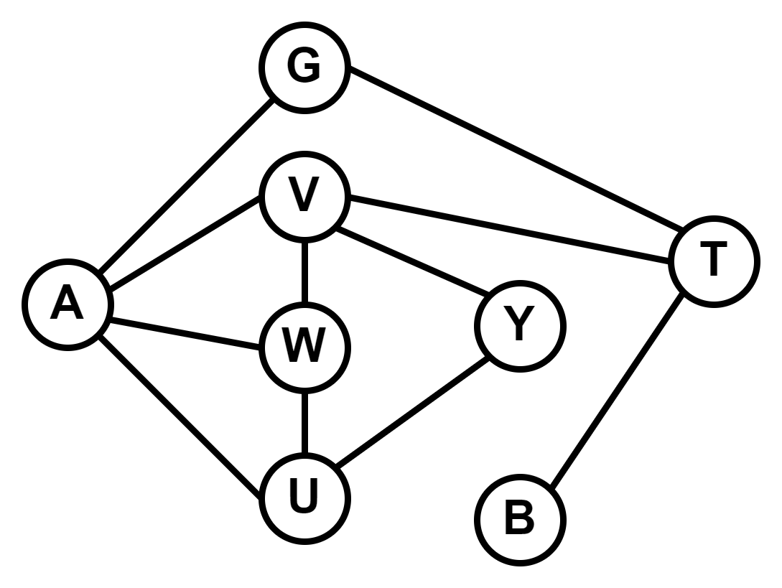  - Give the adjacency matrix representation of this graph.  - Determine whether the Graph is Bipartite/Bicolorable. Show a valid grouping/coloring of the vertices.  - Show a simulation of BFS algorithm with proper use of data structure and other necessary details to find the shortest path from A to B.  Solution:  I  A G V W U Y T B  A 0 1 1 1 1 0 0 0  G 1 0 0 0 0 0 1 0  V 1 0 0 1 0 1 1 0  W 1 0 1 0 1 0 0 0  U 1 0 0 1 0 1 0 0  Y 0 0 1 0 1 0 0 0  T 0 1 1 0 0 0 0 1  B 0 0 0 0 0 0 1 0  II.  No, the Graph is not Bipartite due to the V - W and W - U edges.  III.  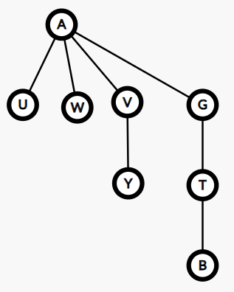  Queue : A G V W U T Y B  Predecessor Pointers :  A G V W U T Y B  NULL A A A A G V T  Shortest Path from A to B : A > G > T > B | 03  02  05

